Press release
Bad Laasphe,
22.04.2022

Author:
Katrin Strübe

Number of characters:
1,243 (including blanks)

Concrete screw JC2 Plus 14
DIBt-approved for reusage into concrete

The ETA-approved JC2 Plus concrete screw for high loads is DIBt-approved for reusability together with the CG Checking Gauge. The CG Checking Gauge is a tool for measuring concrete screw reusability for temporary bracing applications like concrete molds. It allows you to easily check whether the JC2 Plus 14 is suitable for reuse or not. Use before each installation. If the concrete screw can go through the test sleeve, the product should not be used anymore.

The JC2 Plus can withstand high loads even at relatively small spacings and edge distances. Concrete screws are removable and reusable and therefore well suited for temporary fixings such as the installation of element and formwork supports. The JC2 Plus is designed for very heavy loads and the performance is on a top level. The size 14 SW24 is especially designed for attaching formwork supports.

Features of the JC2 Plus:
- Two approved setting depths
- ETA for cracked and non-cracked concrete
- High load capacity
- Optimized thread design for improved cutting performance
- Optimized top shape facilitates installation
- Made in Finland

The full range of JC2 Plus contains size 8, 10 and 14. The JC2 contains size 6.

About EJOT®
The EJOT Construction Division caters to selected segments of the building industry. This includes professional applications on building facades and installation solutions for technical facilities inside the building. The main products are drilling and sealing screws, anchors, mounting elements and profiles for External Thermal Insulation Composite Systems (ETICS), chemical and mechanical anchors as well as fasteners for flat roofs and solar applications.
Whether it is the construction of the highest tower, the most spectacular nuclear reactor protective cover or the southernmost polar station in the world – EJOT customers rely on many years of experience in the building industry.
EJOT – that is more than 3,700 employees in 38 subsidiaries, more than 24,000 products and almost one hundred years of company history.

https://www.ejot.com

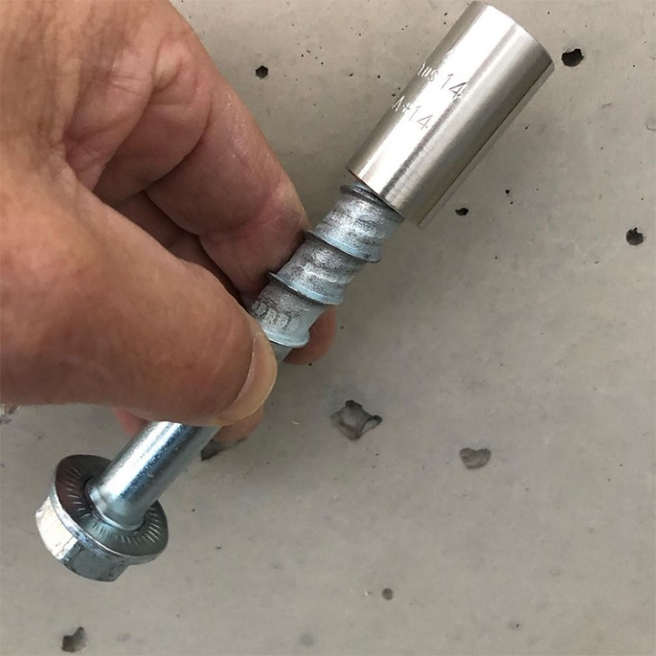
Picture:

The ETA-approved JC2 Plus concrete screw for high loads is DIBt-approved for reusability

Press contact:

EJOT SE & Co. KG
Market Unit Construction

Katrin Strübe
Content Marketing Manager
In der Stockwiese 35
57334 Bad Laasphe

kstruebe@ejot.com
P +49 2752 908-7992
www.ejot.com/construction

