Press release
Bad Laasphe,
19.05.2022

Author:
Katrin Strübe

Number of characters:
1,418 (including blanks)

Certification for worldwide use
FM approval for EJOT flat roof products

A wide range of EJOT flat roof fasteners has been tested and approved for use by the American FM Approvals testing institute in combination with various types of roofing membranes. The necessary tests for this approval essentially correspond to the European approval ETA and confirm the safety, reliability and durability of the EJOT flat roof fasteners. The FM approval is a further step for the worldwide use of the products.

The background: In Europe, fasteners are usually tested on the basis of an EEAS and thus approved for use with all roofing membranes. However, the American FM Approvals testing institute, which is connected to the global insurance company FM Global, tests the entire system consisting of fastener, substructure, insulation material and roof sheet in an individual test. A comprehensive series of tests with various fastener/roofing membrane combinations has now been approved by FM Approvals.

An increasing number of investors and building owners in Europe are demanding the American quality certificate (FM Approvals Standard 4470). FM approval can be relevant for construction projects of internationally operating companies. These are already required in the tender in order to comply with FM Global's insurance standards.

A list of all approved products is available from the central Roofnav database (www.roofnav.com).

About EJOT®
The Market Unit Construction caters to selected segments of the building industry. This includes professional applications on building facades and installation solutions for technical facilities inside the building. The main products are drilling and sealing screws, anchors, mounting elements and profiles for External Thermal Insulation Composite Systems (ETICS), chemical and mechanical anchors as well as fasteners for flat roofs and solar applications.
Whether it is the construction of the highest tower, the most spectacular nuclear reactor protective cover or the southernmost polar station in the world – EJOT customers rely on many years of experience in the building industry.
EJOT – that is more than 3,700 employees in 38 subsidiaries, more than 24,000 products and one hundred years of company history.

https://www.ejot.com

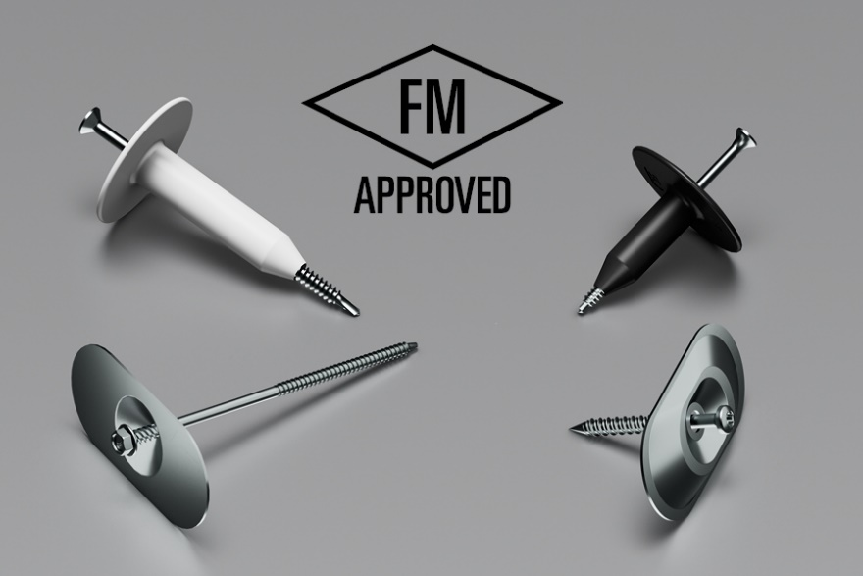

Picture:

EJOT flat roof fixtures have been approved by the American FM Approval testing institute.

Press contact:

EJOT SE & Co. KG
Market Unit Construction

Katrin Strübe
Content Marketing Manager
In der Stockwiese 35
57334 Bad Laasphe

kstruebe@ejot.com
P +49 2752 908-7992
www.ejot.de/bau

