Press release
Bad Laasphe,
13.07.2022

Author:
Katrin Strübe

Number of characters:
1,759 (including blanks)

EJOT® JC2 concrete screws
Additional embedment depths and approved reusage

The EJOT concrete screws from the JC2 family have long proven their true versatility. With the ETA revision and a new national approval, the possible applications of the products have been considerably expanded.

An additional, reduced embedment depth of 35 mm is now possible for multiple fastening of non-load-bearing systems in concrete (ETA 18/0221) using the JC2 concrete screws with a diameter of 6 mm and hexagon head (KB), truss head (FR) or countersunk head (ST). As well as the two installation depths of 35 or 40 mm for multiple fastening, a third installation depth of 55 mm can now be used for single fastening. This gives contractors even greater flexibility for application while at the same time reducing the risk of colliding with the installed reinforcement during fastening.

The new approval Z-21.8-2141 regulates the option of reusing the JC2 Plus concrete screw, 14 mm diameter with hexagon head. The ETA-approved JC2 Plus concrete screw for high loads is approved by German Institute for Building Technology (DIBt) for reusage in combination with the EJOT checking gauge. The checking gauge is a tool for measuring the reusability of the JC2 Plus concrete screw for temporary bracing applications like concrete molds. The check must be made before each reuse. If the concrete screw can go through the test sleeve, the product must no longer be used.

JC2 concrete screws are screwed directly through the attachment into the substrate. By doing so, the thread cuts into the concrete, creating a mechanical serration across the total embedment depth. No expansion forces occur during installation, making them particularly suitable for temporary fastenings near the edge.

About EJOT®
The EJOT Construction Division caters to selected segments of the building industry. This includes professional applications on building facades and installation solutions for technical facilities inside the building. The main products are drilling and sealing screws, anchors, mounting elements and profiles for External Thermal Insulation Composite Systems (ETICS), chemical and mechanical anchors as well as fasteners for flat roofs and solar applications.
Whether it is the construction of the highest tower, the most spectacular nuclear reactor protective cover or the southernmost polar station in the world – EJOT customers rely on many years of experience in the building industry.
EJOT – that is more than 3,700 employees in 38 subsidiaries, more than 24,000 products and one hundred years of company history.

https://www.ejot.com

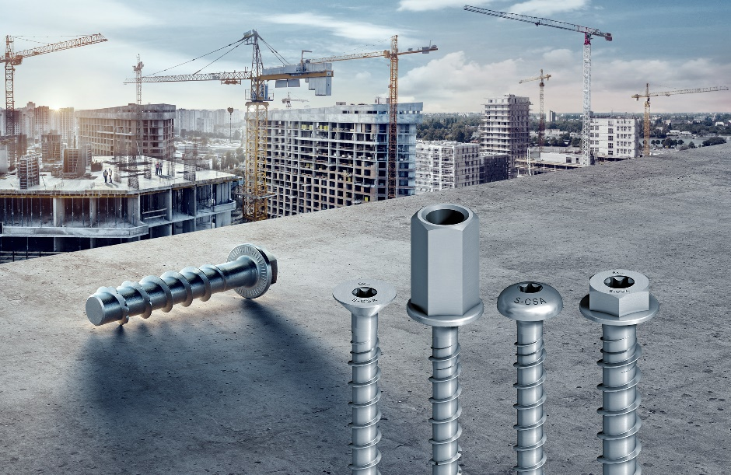

Picture:

Concrete screws of the EJOT® JC2 family are now approved for additional embedment depths and reusage

Press contact:

EJOT SE & Co. KG
Market Unit Construction

Katrin Strübe
Content Marketing Manager
In der Stockwiese 35
57334 Bad Laasphe

kstruebe@ejot.com
P +49 2752 908-7992
www.ejot.com

