Press release
Bad Laasphe,
06.10.2022

Author:
Katrin Strübe

Number of characters:
3,824 (including blanks)

Ecological and sustainable
Topping-out ceremony of the new EJOT TecCenter in Bad Laasphe

Ecology and efficiency play a central role when it comes to the new TecCenter at the EJOT site in Bad Laasphe. They underline the strategic goal of the family-owned company. Reducing the CO₂ emissions to zero by the year 2035, thus achieving climate neutrality.

"A great building to develop excellent products." This is how Christian Kocherscheidt, managing partner of the EJOT Group, summed it up in a very simple way at the topping-out ceremony of the TecCenter on September 30th, 2022. During the tour, the more than 100 guests learned that there is much more behind the planning and execution of the new building complex, which will be ready for occupancy in May 2023 for parts of the EJOT Market Unit Construction. EJOT is investing about ten million euros in this project.

"In terms of construction, we are moving with the times," emphasised architect Prof. Burkhard Pahl from PWP Planungsgesellschaft in Darmstadt when presenting the building concept. It is not only about resource-saving construction and management, but also about new approaches such as "life cycle costs". The complete life cycle is taken into account - meaning the development from the product idea to the deconstruction. Experts call this circular construction.

Wood is the dominant raw material for the TecCenter: A supporting structure made of high-strength structural beech, walls made of wood sandwich panels (CLT technology), ceilings as board stacks, partly as wood composite ceilings, office partition walls made of wood stud walls with clay building panels. Charging points for e-mobility in front of the building, green facades, green retention roofs for water retention, photovoltaics and geothermal energy with heat pump complete the holistic concept. The TecCenter with "passive house character" thus fulfils the increased KFW 40 subsidy standards which require CO₂ neutrality in operation. The federal government's subsidy for this innovative concept is about one million euros.

"Today, we are more and more interested in the ecological footprint of a building and need clarity about the composition and harmlessness of the ingredients," Burkhard Pahl explained. The entry into this world of thought is recognizable in the new TecCenter, he said: the building stands on about 400 mineral, water-permeable gravel columns and on a pack of foamed waste glass. Petroleum-based insulating materials are dispensed with, plasterboard is largely avoided, and energy-intensive tiles are dispensed with altogether.

The rectangular building has a floor area of 24 x 53 meters. It is partially two-story and modular. A look at the shell gives the impression of a modern, bright, open, but equally clear and simple design.

On the ground floor there is a large area especially for customers, who can also experience EJOT there in 3D as part of an "augmented reality". The showroom offers a lounge atmosphere and products to touch. The large seminar room for about 60 people may remind one of a lecture hall, another large meeting room and catering facilities complement this area. In addition, there are technical facilities such as workshops, test benches, climate chambers for conditioning wood and plastic, a room for 3D printers, as well as a digitally equipped creative room, which is a meeting room, workshop and functional room in one.

The upper floor mainly houses the offices and meeting rooms for the technical departments, but also a number of shared offices that can be used flexibly (e.g., for employees who are temporary working at the site and need a workspace for a while).

"We want to open up new customers and business fields. The special focus is that we succeed in developing the best, the most innovative products for our customers." This spirit, says Christian Kocherscheidt, is to be conveyed with the new TecCenter in Bad Laasphe.

About EJOT®
The EJOT Construction Division caters to selected segments of the building industry. This includes professional applications on building facades and installation solutions for technical facilities inside the building. The main products are drilling and sealing screws, anchors, mounting elements and profiles for External Thermal Insulation Composite Systems (ETICS), chemical and mechanical anchors as well as fasteners for flat roofs and solar applications.
Whether it is the construction of the highest tower, the most spectacular nuclear reactor protective cover or the southernmost polar station in the world – EJOT customers rely on many years of experience in the building industry.
EJOT – that is more than 3,700 employees in 38 subsidiaries, more than 24,000 products and one hundred years of company history.

https://www.ejot.com

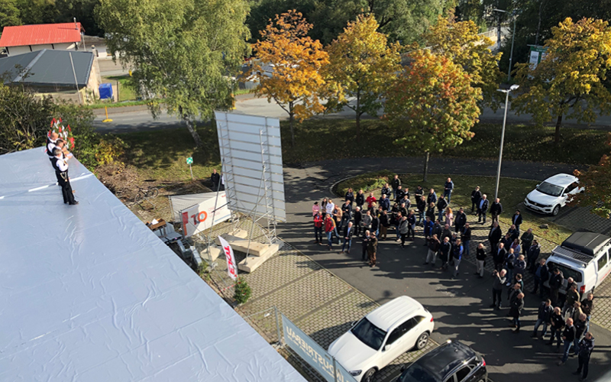

Picture:

Around 100 guests came to the topping-out ceremony of the EJOT TecCenter in Bad Laasphe on September 30th, 2022

Press contact:

EJOT SE & Co. KG
Market Unit Construction

Katrin Strübe
Content Marketing Manager
In der Stockwiese 35
57334 Bad Laasphe

kstruebe@ejot.com
P +49 2752 908-7992
www.ejot.com

